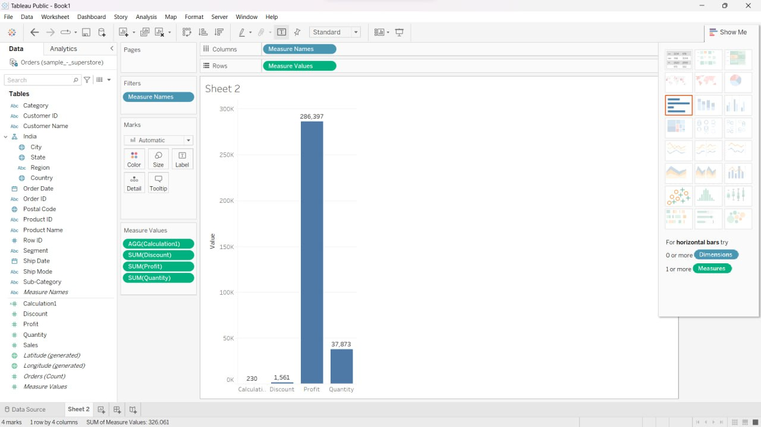Question 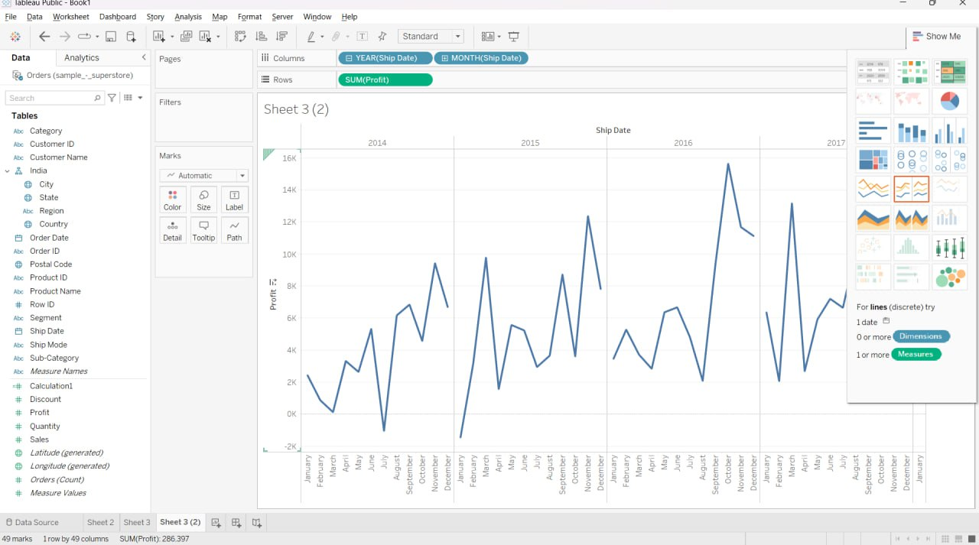3

Question1

Question 7

Question 6

Question5

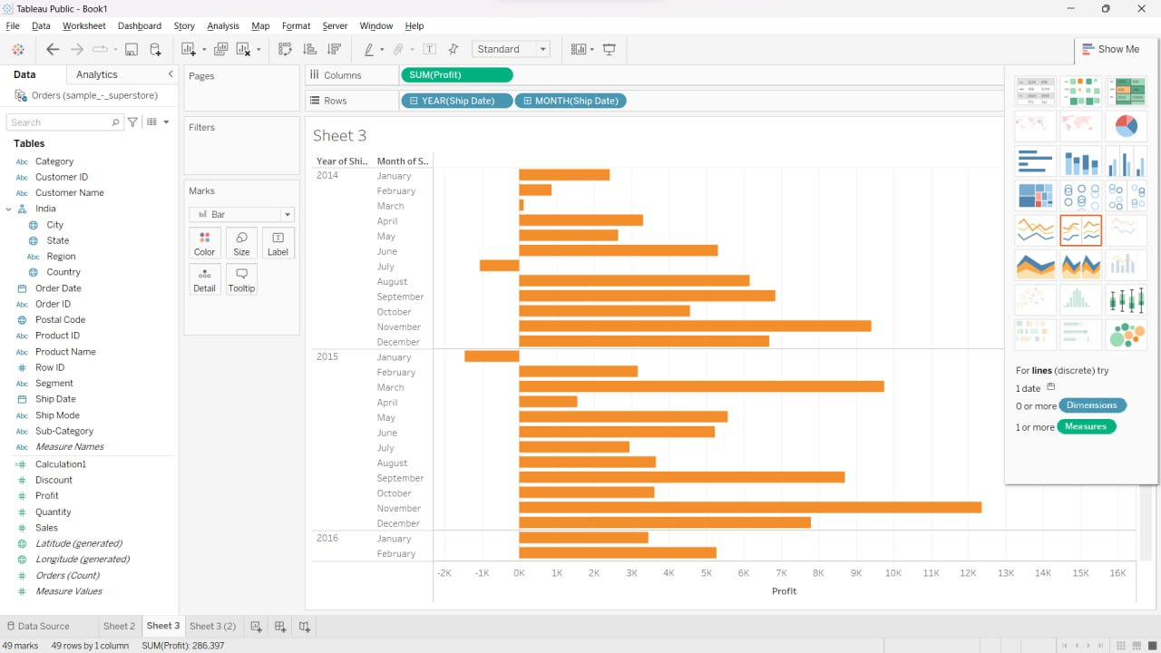question 2

Question4